Practical no.5

**Title:** Program related to dictionary

5.1) Program based on dictionary:

Code:

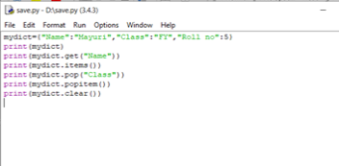

Output:

